WFSC 448 – Fish Ecophysiology
(Week 1; 24 Aug 2022)

An upper level class in how fish perform and sustain their populations in a complex, environmentally dynamic world—A course bigger and broader than others so far, with learning goals that will make you a powerful thinker and problem-solver.

The anatomy and physiology of a fish (or any organism) is an adaptive interface system for the environment. This interface sustains and propagates genes. The interface, composed of many organ systems and biochemistries, is also created by the genome. Fish use these organ systems, and many systems not depicted here, to interact with their aquatic environment composed of both physical and biotic components. This makes the topic of fish ecophysiology seem straightforward. Yet it is vastly more complicated than you might imagine. This complexity is important to understand, for example to manage natural populations, but also provides a great depth of intellectual satisfaction.
Learning outcomes/goals for course
● Learn to think integratively (build conceptual framework with information from different domains)
● Learn to think creatively (come up with ideas no one else has thought)
● Learn to think thoroughly (carry through logical scenarios to distant yet probable ends)
● Learn to think about connectedness of physiological systems, ecological systems, and physio-eco couplings
● Read a lot of scientific literature (gain facility extracting information; gain information)
● Learn to critically evaluate experimental designs (understand replication, treatments, random effects, temporal and spatial frames, dosages, interactions, and both statistical significance and power)
● Learn to think quantitatively (e.g. understand statistics, modeling)
● Learn ecology and physiology of fishes
● Practice preparing and delivering an oral presentation
● Practice scholarly oral discourse
● Spark and feed your sense of wonder about nature

Learning how to learn from Dr. DeWitt
● Recognize that isolated facts you learn may be boring, but their synthesis is sublime.
● Memorizing facts is not learning in a very meaningful sense.
● Learning concepts is deeply meaningful.
Developing new concepts is sublime.
● Learning to reflect, to twist facts and concepts into new syntheses,
and project to new domains is the goal.
● Concept rotation (lateral thinking)…
● Don’t stop: Concept follow-on/carry-through

How to study without a text?
● Lecture notes point to concepts that should be understood
● Primary literature assigned points to important concepts and
provides detail.
● My ‘tangents’, if they have information content, are important.
● Rely on the above points to know what detail to learn and fill-in your
conceptual frameworks with additional material (e.g. Wiki’s, literature
you find, etc.).
● Pay attention to emphasis cues: underlining, font color, figures, tables, readings assigned, verbal statements—“you need to know this”, “understand this concept”…
● External content is important—that is why I provide links in the notes
and course page to external content I use—so you can review the material outside
of class.
● Take responsibility for learning the concepts well enough to do
something with them—like connect with other concepts.

A strong emphasis in the course is adaptational biology, taken both to mean short term physiological accommodations to the environment and long term evolution. Read the Bennett chapter on the course page.

Why this ‘adaptation’ emphasis?
● Evolving fit for the environment has produced the vast diversity of
organismal form we see on the tangled bank.

● This diversity in its full complexity we must understand to protect, sustain, and promulgate.
● Evolving fit for the environment has produced the vast diversity of
internal systems of control, each coevolved to maintain internal
homogeneity and maximize external synergy.
Examine syllabus & discuss class structure, grading, etc…
Fig B1. Two causal models. Left: Two traits (z₁, z₂)
influence performance (f) and performance determines fitness (w). Right: Direct paths from traits to fitness test latent effects.
Fig B2. Complex environmental effects on traits. Fish body shape depends on direct and indirect effects of water flow.
Box 1. Case studies demonstrating costs of missed complexity
“Other factor” intrusions: Latent (neglected) variables and interactions
1. In a study of trait-mediated survival of a stem-galling parasite, selection intensity was under-estimated by 6% if trait interactions were neglected and by 9% if traits thought to be out of scope (in the original study) were neglected. For another trait, selection was found to be 11 times greater, opposite in sign, and significant only when interactions were included (Curr Zool 10.1093/cz/zow085).
2. In a study on predator-prey interactions, selection on a (snail) prey trait due to one predator (decapod) was completely reversed in the presence of another predator (fish). As well, predation rate by a given individual predator (decapod) was doubled by the presence of the other predator (J Sea Res 49:143-155).
Complexity through structured causation
3. Organismal fitness accrues through intermediary effects of traits on performance (Fig B1). We found the impact of a predator (aquatic insect) on prey (tadpole) survival was wrongly characterized if latent functional hypotheses were neglected in an appropriate path analysis (Evolution 62: 1243–1251).
4. Environmental covariance, such as flow and oxygenation in rivers, can obscure component effects.
A structured data model of these effects on fish body shape revealed flow impacts body shape in two ways that obscure each other. There is a direct effect of flow detectable only if one also models the indirect effect of flow on oxygen, oxygen on gill size, and gill size on
body shape as in Fig B2 (J Evol Biol 20:1171–1181).

Thought experiment—what is ecophysiology?

Let us construct a conceptual framework going into the semester about what ecophysiology is, which framework will be ready for expansion and filling-in as the semester proceeds.

We will graphically forge a synthetic definition of “ecophysiology” and think through at least 3 disparate examples of such work from the literature. Consider as chronic homework the refinement and expansion of this graphical definition througout the semester. Be able to spontaneously convey your grand conception of ecophysiology. You may focus on ecophysiology taken broadly or fish ecophysiology if it helps your personal internal narrative.

Realize this is an effort to get students at the event horizon of the class to take ownership of this topic and prepare for the semester ahead.

Topics | Intro to EcoPhys; Physical properties of water; Physiology of oxygen

Physiology| Physiology emcompasses the functions performed by organ systems and biochemistry, such as internal regulation and the control
and manifestation of behavior and development.

Ecophysiology| Ecophysiology a biological discipline that studies the adaptation of an organism's physiology to environmental conditions.

Context | Habitats are diverse and require organisms to adapt to varying conditions, biotic and abiotic factors change environment.

Use | This discipline can be used to understand the environmental conditions that fish need and how humans, other organisms, and natural processes affect fish populations. Learning ecophysiology can be helpful in a career in fisheries or wildlife management or research. Knowledge of organismal function can be useful in future management of animals and their habitat.

Examples:

Physiology is multifaceted and complex. Many mechanisms create impacts on organismal vigor, abundance, and distribution. Illustrated here are some impacts of temperature.

● Shofield and Loftis of the USGS studied the ecophysiology of Hemichromis letourneuxi, the African Jewelfish, an invasive species in the Everglades (and Canadian Rockies).
They observed it’s physiological responses to hypoxia, salinity, and temperature in order to predict its possible distribution throughout Florida.
- Lee B. Astheimer and William A. Buttemer looked at how the breeding biology of Australian birds changes due to an aridity. Several species show flexible, or opportunistic, breeding instead of seasonal breeding.
- Dr. Gatlin studied effects of various probiotics on growth characteristics in aquaculture species. This improves fish yield but also improves the life of fish in captivity.
- Sand crabs (Emerita analoga) develop varying cephalothorax shape depending on coarseness of sand (Veas et al. 2014) and Kolluru et al. (2011) showed that parasite infection also impacted burrowing time. Let’s think through some causes consequences and work the logic through as far as possible.
- Stress such as crowding and mercury pollutants activate the HPI (hypothalamic-pituitary-interrenal axis) that affects reproduction.

Kolluru GR, Green ZS, Vredevoe LK, Kuzma MR, Ramadan SN, Zosky MR (2011) Parasite infection and sand coarseness increase sand crab (Emerita analoga) burrowing time. Behav Processes 88: 184-91. doi: 10.1016/j.beproc.2011.09.004.
Rankin JC (1993) Endocrine Response to Environmental Conditions. Pp. 105-135 in Fish Ecophysiology. Vol. 9. Springer, Netherlands.
Veas R, Hernández-Miranda E, Quiñones RA (2104) Body shape and burial behavior of the sand crab Emerita analoga (Stimpson 1857) in a reflective to intermediate morphodynamic range of sandy beaches. Marine Biology 161: 2345–2357.

Major point: Physical and chemical properties of water dominate lives of aquatic organisms in ways largely alien to terrestrial vertebrates

Physical nature of water—
setting for the ecology and physiology of fishes…

“The primary goal is to reduce suffering and to do that one must understand the world.” —Buddha

Mankind has done a fair job of discerning the nature, workings, and history of the physical world. Here’s what we have been able to piece together:
- 14 bya the universe was formed
- 4.5 bya our planet was formed
- contained key ingredients for emergence and maintenance of life, which arose 3.8 bya

On the latter point, water, carbon dioxide, nitrous oxides, and mineral ions in liquid water started life. Water is the lynchpin. For in water, the chemistry of life, no matter what form it was to take, was possible. Obviously it took the form of what you see today… cellular, nucleic-acid based self-replicating organisms. The dawn of autopoeisis changed the world and began the path to our fish-like existence. "Autopoiesis" (αὐτo- meaning "self"; ποίησις meaning “creation ") refers to a system capable of creating (reproducing) itself. Archaea started things off and gave rise in one or a few lineages to the eukaryota, and later to fishes. In fishes there evolved a basic set of organ systems and concomitant physiologies that enabled the evolution of a diverse array of vertebrates including things like dinosaurs and humans. Phylogenetically, we are all fish. This is so because of common descent—if one follows our phylogeny back on the tree of life, one sees we connect, albeit 200 MYA to fish and are “monophyletic” with them. Traits that make us human, even spiritually as love, greed, passion etc., are evolutionary adjustments to the systems evolved in fishes.

This is all context and a segue to ask: What are the major difference(s) between terrestrial and aquatic vertebrate life, and why do these differences exist?

Water Physical Sciences I (chemistry)

Overview
Water is dihydrogen monoxide, H₂O. It has extremely unique properties that make it vital for probably all life processes, and these properties also make it a major constraint for physiological systems. The structure of water is as follows. Note that oxygen has two electrons to share and hydrogen in its ionic state (a proton, when dissolved in water) has a single electron deficit—thus two H bond to one O:
The electron surplus for the O creates a negative charge on its side of the molecule, with positive charge on the 2H side. Because of this shift in charge across the molecule we call water a polar molecule.

Water’s polarity allows it to interact with so many other molecules it is called the “universal solvent”.

Water even interacts with itself:
Hydrogen bonds hold liquid water together.
Largely responsible for high viscosity, density and hence
mass of water.

Normal orientation of water molecules:

FYI: Polarity also allows water to interact with an electric field.

Disrupted orientations

This is how the composition of water was discovered by Lavoisier.

<FYI>Antoine Laurent Lavoisier (1743-1794) is considered to be the father of modern chemistry. He discovered the composition of water by running electric current through liquid water. The electric field breaks up liquid water’s tight conformation (contrast last two figures) and liberates the component gases. This process is known as hydrolysis (hydro: water; lysis: to cut). Lavoisier quickly found there were two component gases, one lighter than air, and one fundamentally like air. One of the gasses he found could be breathed by animals to sustain life. He named that gas oxygen (oxy: acrid; gen: to make) under the (flawed) idea that it is a component of acids. The other (lighter) gas was flammable—but only in the presence of oxygen. He found when the second gas was burned it makes water, so he called it hydrogen (hydro: water: gen: to make).
So… electricity takes water apart, and fire puts water together.
</FYI>

Water can dissolve (bring into solution as ions) most compounds or elements you can think of…
- solids like iron and rock
- gases like oxygen and carbon dioxide
- and other liquids like sulfuric acid and sodium hydroxide
Here is what water does to table salt: (consider stage performance of scrum interrupted by a herd of skunks)

Water therefore serves as a storage compartment, transfer medium, and chemical mediator for a huge fraction of chemistry on our planet, within organisms, and at the organism-environment interface.

Imagine the dissolution of your favorite mineral or gas:

2H₂O + SO₂ + SO₄⁻⁻ 2H₂S0₄
Or
CO₂ + H₂O 2H⁺ + CO₃⁻ ⁻

What effect would you suppose this reaction has on fish?

Other Unique Properties of Water
- As for most substances, water becomes more dense as temperatures drop. Except as temperature drops below 4 °C water grows less dense and solidifies at 0 °C.
- Water has high molar heat capacity allowing it to adsorb and emit relatively large amounts of heat without a change in temperature
- Water has large latent heats of evaporation and freezing as a result of hydrogen bonds, with the result that phase changes of water are an important heat-transport vehicle
- Strong cohesion & adhesion (surface tension & capillary action)
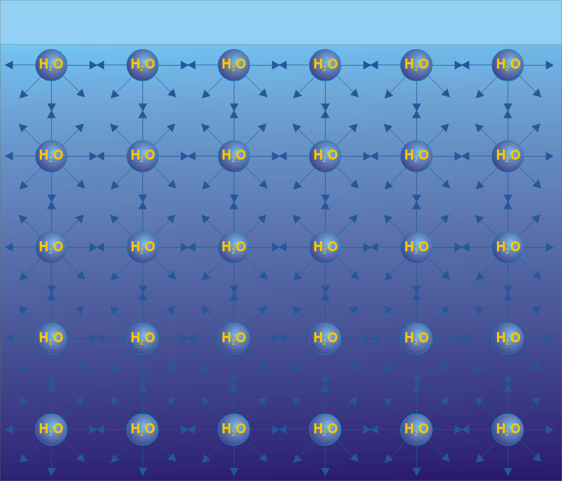
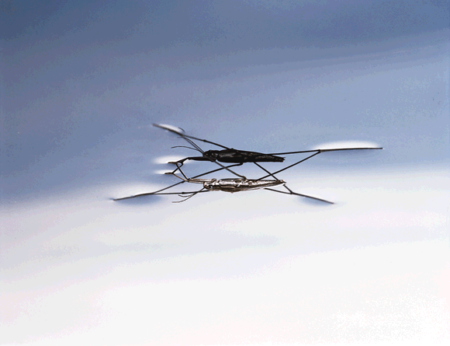
water (dyed) mercury

What are some important consequences you can think of regarding water’s high cohesion and adhesion?

More fun with the properties of water: cohesion, adhesion, capillary action and surface tension:
http://science.jrank.org/pages/1182/Capillary-Action.html
(Note the video at the bottom begins slow but gets good)

Ponder: Why does rain fall in drops? Why not cubes?

<joke> (H₂O)³ = chemical formula for ice cubes. —Dr. DeWitt </joke>

Major point: Physical and chemical properties of water dominate lives of aquatic organisms in ways largely alien to terrestrial vertebrates

Dimensionality—3D world; requires perceptual shift regarding orientation, different modes of locomotion

Viscosity, Density—Density slows movement and demands streamlining (we must look ridiculous to fish; any wonder why such strong convergence of cetaceans and fish?). Makes water heavy and sticky. Sensory biology of lobsters example—apply to fish (Wisenden pelvic flick).

Solvent properties—Water can bear a great deal of solute
- Intimacy—when you are in water you are really IN it.
- Oxygen capacity—
  - Air is a constant 20% oxygen, 285 mg·l⁻¹
  - Water is 9 mg·l⁻¹ (at 20 °C) and varies [know magnitude of difference]
    - Draw two oxygen profiles, one with temp, one with time
  - It’s variability that really gets you—homeostasis is tough enough to achieve in constant environments!
  - Compounded problems…
    - Fish must pump a very heavy medium across their respiratory surfaces
    - Fish must pump a much greater volume of medium across their respiratory surfaces
    - What else do the physical and chemical properties of water imply for this pumping
    - Heat exchange (water has high specific heat capacity)
    - Chemical exchange (water is polar; universal solvent)

So practice thinking through implications of water’s properties for aquatic organisms.

Oxygen stress… hypoxia vs. oxidative stress.

Hypoxia is low oxygen in the environment. Oxidative stress is oxygen radicals in the body.

An interesting vignette on oxidative stress (excerpted from Braunbeck, Hinton & Streit (1998) Fish Ecotoxicology: Birkhäuser). Toxins in the environment require oxygen to be defeated in the body, but that presents its own physiological (biochemical) problems.

Recent, super relevant/important example:
Dasgupta et al. (2015) – at least know material, esp. major point from the abstract.
Dasgupta S, Huang IJ, McElroy AE (2015) Hypoxia enhances the toxicity of corexit EC9500A and chemically dispersed southern louisiana sweet crude oil (MC-242) to sheepshead minnow (Cyprinodon variegatus) larvae. PLoS One 10: e0128939. http://dx.doi.org/10.1371/journal.pone.0128939
Example of how ox phys interacts across functional domains in fish physiology.
Corexit = bad. Corexit + hypoxia exponentially worse than either problem alone.

Good lesson in phenotypic deformation theory (DeWitt phrase) wherein if one tugs on one thread of the physiological tapestry, deformation of other processes will likely propagate. Or concisely: the fix for one problem presents new problems.

PTD is the physiological equivalent of the Muir quote about ecology:
"When one tugs at a single thing in nature, he finds it attached to the rest of the world."
—John Muir, My First Summer in the Sierra (1911 p. 110)

Our focus with respect to oxygen will be hypoxia, as it is perhaps the most pervasive ecological problem faced by fishes.

So what are the direct and cascading effects of hypoxia on fish physiology? (Carry it though)

Maybe get used to looking at this figure to stimulate thought:
Hint: be sure to think through all trait types (behavior, morphology, physiology, life history) and at all levels of biological organization (molecular, genetic, developmental, cellular, organ systems, etc.) and interactions, in the context of diverse environmental conditions.

So what is a fish to do in response to hypoxia? (Carry it though)

Some references on things known:

Behavior

ASR, increased ventilation, “anal breathing”, tail breathing (original idea—most likely true), habitat choice, activity change (e.g. reduction). See more ideas here.

During aquatic surface respiration (ASR), fish use the uppermost layer of water that is generally richer in oxygen than deeper in the water column. This widespread adaptation to hypoxia is present in many different fish families. Contrary to popular belief, ASR does not involve air-breathing.

—Photo and caption from USGS (link).

Sidebar:
Another creativity tool—Wilcoxian observation. Water strider, Portia examples.

Molecular
Oxygen carriers transduce titer signal and impact gene expression and so altering physiology, including endocrine cascades that alter behavior, autonomous processes, and genetic regulation that induce plastic development or remodeling, or direct physiological shifts (e.g. profusion of epidermal capillaries), etc.

Developmental
Gill volume plasticity. What else (longer fins, greater vascularization…)

Lauren Chapman work (readings posted to web).

Tips on reading scientific papers: nice lifehack here

